* **Machine Learning Phases:**
  + Two phases in machine learning: training and inference.
* **Data in Machine Learning:**
  + Emphasis on data being central to machine learning.
  + ML problems are fundamentally about data.
* **ML Model Production Steps:**
  + Steps involved in delivering an ML model to production.
  + Process can be manual or automated.
* **Data Extraction:**
  + Retrieving data from various sources.
  + Sources can be structured (CSV, JSON, XML) or unstructured (images, text, streaming data).
  + Examples of unstructured data sources (e.g., books, journals, audio, video).
* **Data Analysis:**
  + Exploratory data analysis (EDA) to understand extracted data.
  + Identification of outliers, anomalies, trends, and data distributions.
  + Goal: Enhancing predictive power of the ML model.
* **Data Preparation:**
  + Transforming data format, structure, or values.
  + Tasks include data cleansing, altering data types, converting categorical data.
  + Various ways to prepare or transform data for ML models.
* **Data Quality Assessment:**
  + Evaluation of data quality in organizations.
  + Attributes: accuracy, timeliness, completeness.
  + Measurement of timeliness as the time between expected and available information.
  + Data completeness: whether all intended data is complete in the dataset. 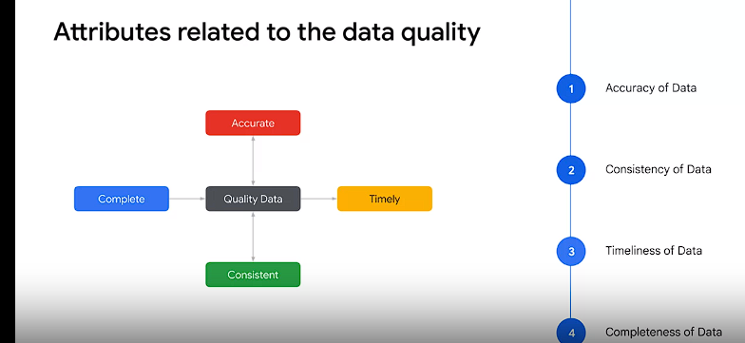
* **Improving Data Quality:**
  + Methods include resolving missing values, converting datetime features, parsing datetime features, removing unwanted values, and using one-hot encodings for categorical data.
  + Example illustrating the impact of missing values on data.

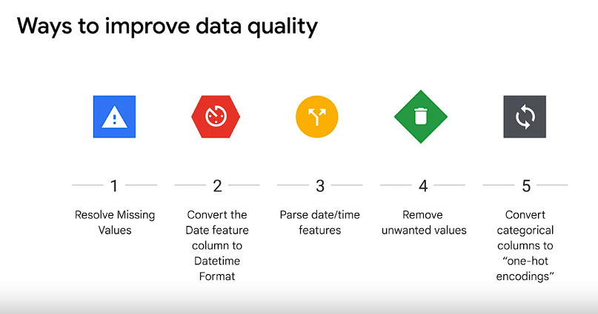

* **Handling Messy Data:**
  + Exploration of untidy or messy data examples.
  + Dealing with issues like datetime format and unwanted string characters.
  + Importance of strategic decisions in handling data quality issues.
* **One-Hot Encoding:**
  + Explanation of one-hot encoding for dealing with categorical data.
  + Generating Boolean columns for each category or class.
  + Importance of data quality in influencing the predictive value of an ML model.
* **Conclusion:**
  + Iterative and non-sequential nature of data exploration and cleaning.
  + Emphasis on the significance of data quality throughout the ML process.
* **Focus on Data Quality:**
  + The lab's main focus is on improving data quality.
* **Numeric Data Requirement:**
  + Reminder that Machine Learning models can only consume numeric data.
  + Emphasis that numeric data should be in the form of ones or zeros.
* **Definition of Messy or Untidy Data:**
  + Messy or untidy data is characterized by various issues:
    - Missing attribute values.
    - Noise or outliers.
    - Duplicates.
    - Wrong data.
    - Upper/lowercase column names.
    - Data not ready for ingestion by a machine learning algorithm.
* **Common Issues Addressed in the Lab:**
  + Solving missing values in the data.
  + Converting data feature columns to a datetime format.
  + Renaming a feature column.
  + Removing a value from a feature column.
  + Creating one-hot encodings.
  + Examples of temporal features conversions.
* **Note on Problem-Specific Methods:**
  + Recognition that different problems may require different methods.
  + Acknowledgment that such methods are beyond the scope of this lab.
* **Lab Workflow:**
  + The lab begins by addressing missing values.
  + Conversion of data feature columns to a datetime format.
  + Renaming a feature column.
  + Removal of a value from a feature column.
  + Creation of one-hot encodings.
  + Examples of temporal features conversions.
* **Conclusion:**
  + The lab provides solutions to common issues in untidy data.
  + Acknowledgment that more complex problems may require additional methods, which are not covered in this lab.

Supervised Learning

* **Supervised Learning:**
  + Subset of machine learning where the model receives labeled examples.
  + Two common classes in machine learning: supervised and unsupervised.
* **Difference Between Supervised and Unsupervised Models:**
  + In supervised models, there are labels or correct answers for predictions.
  + Unsupervised learning deals with **data lacking labels**.
  + Illustration of an unsupervised problem where clustering is applied to tenure and income data without ground truth.
* **Discovery in Unsupervised Learning:**
  + Unsupervised problems are about discovery, looking at raw data to identify natural groups.
  + Example of clustering employees based on tenure and income.
* **Focus on Supervised Learning in the Course:**
  + Course emphasis on supervised machine learning problems.
  + Critical difference: supervised learning involves having labels or characteristics for each data point.
* **Supervised Learning Example:**
  + Example scenario: a waiter predicting tips based on historical data.
  + Historical tip data serves as a label, and other known factors (predictors) are used to predict tips in real-time.
* **Two Types of Supervised Learning Problems:**
  + Classification and regression are the two types of supervised learning problems.
  + Regression deals with continuous labels.
  + Classification deals with discrete labels having a finite number of values or classes.
* **Tip Data Set Example:**
  + Example data set of tips with characteristics such as total bill, tip, and sex.
  + Each row is called an example, and columns are features.
  + Explanation of model options for predicting tip amount or customer sex.
* **Model Options:**
  + Model Option 1: Predicting tip amount using one or more columns as features. Regression model due to the continuous label.
  + Model Option 2: Predicting customer sex using other columns as features. Classification model due to the discrete label.
* **Determining Machine Learning Models:**
  + The problem, data, and desired explainability influence the choice of machine learning models.
  + Unlabeled data leads to the use of clustering algorithms for discovery.
  + Labeled data allows for supervised learning with classification or regression algorithms.
* **Label Considerations:**
  + Dog breed as a labeled discrete quantity suggests using a classification algorithm.
  + Dog weight as a labeled continuous quantity suggests using a regression algorithm.
  + The label is what is being predicted in supervised learning, and its nature determines the appropriate algorithm.
* **Conclusion:**
  + Supervised learning involves having data with correct answers (labels).
  + Different types of problems and data characteristics influence the selection of machine learning models.

Top of Form

1. **Option 1: Regression Problem - Predicting Tip Amount:**
   * Using the tip amount as the label.
   * Regression problem due to the continuous nature of the tip amount.
   * Goal is to predict a continuous value using mathematical functions.
2. **Regression with One Feature:**
   * Illustrated with a line representing the relationship between total bill amount and tip amount.
   * Example of calculating the predicted tip using a tip rate (e.g., 18%).
3. **Multi-Dimensional Regression:**
   * Generalization to multiple features in a multi-dimensional problem.
   * Features' values multiplied by the gradient of a hyperplane to predict a continuous label.
4. **Error Minimization in Regression:**
   * In regression problems, the goal is to minimize the error between predicted and actual continuous values.
   * Mean squared error is commonly used for this purpose.
5. **Option 2: Classification Problem - Predicting Sex:**
   * Treating sex as the label.
   * Classification problem due to the categorical nature of sex (male or female).
6. **Decision Boundary in Classification:**
   * Objective is to create a decision boundary separating different classes.
   * Linear decision boundary discussed, but challenges highlighted in this specific case.
   * Reference to cross entropy as a metric to minimize misclassification errors.
7. **Tip Amount Classification:**
   * Suggestion to categorize tip amounts (high, average, low) for classification purposes.
   * Discretizing tip amounts to create a classification problem.
8. **Regression and Classification as Prediction Problems:**
   * Both regression and classification can be viewed as prediction problems.
   * Contrast with unsupervised problems, which are more descriptive in nature.
9. **Source of Structured Data:**
   * Mention of the tips dataset as an example of structured data.
   * Structured data consists of rows and columns.
10. **Structured vs. Unstructured Data:**

* Unstructured data includes pictures, audio, or video.
* Example of a medical information dataset in BigQuery for structured data.

1. **Predicting Gestation Weeks Example:**

* Using SQL SELECT statement in BigQuery to create an ML dataset for predicting gestation weeks.

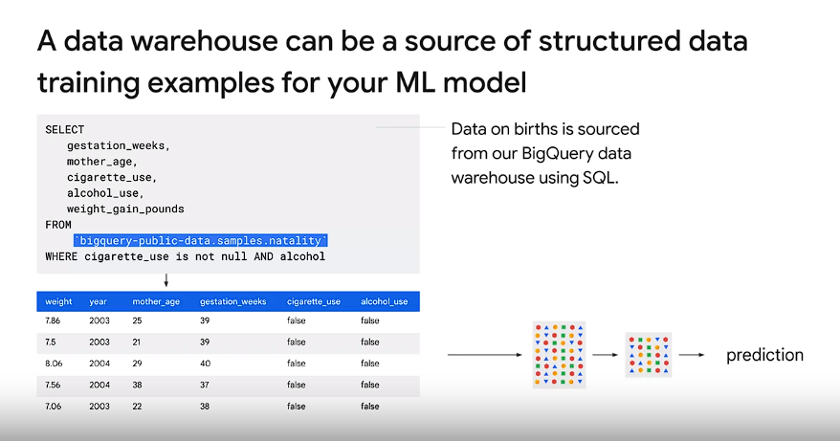

* Gestation weeks as a continuous label leads to a regression problem.

1. **Predicting Baby Weight Example:**

* Exploring another prediction scenario: predicting baby weight.
* Baby weight as a continuous variable, making it suitable for regression.

1. **Linear Regression and Linear Classification:**

* Discussing the dataset's suitability for both linear regression and linear classification.
* Introduction of a noisy dataset with two linear series.

1. **2D Linear Regression for Classification:**

* Performing 2D linear regression predicting Y from two features: x and class.
* Creating a 2D hyperplane to separate data points based on the class dimension.

1. **Comparison with Logistic Regression:**

* Comparing the output of logistic regression (linear classification) with 1D linear regression.
* Explaining the differences in loss functions (mean squared error vs. cross entropy).

1. **Data Set's Suitability for Both Regression and Classification:**

* Demonstrating that the dataset is a good fit for both linear regression and linear classification.
* Contrast with the tips dataset, which was better for non-linear classification.

This comprehensive breakdown covers all the major points discussed in the provided module. **regression models usually use mean squared error as their loss function, whereas classification models tend to use cross entropy.**

Top of Form

The given text provides a comprehensive overview of logistic regression, emphasizing the importance of regularization in this context. Here's a summary and breakdown of the key points:

1. **Introduction to Logistic Regression:**
   * Logistic regression is introduced as a method for predicting outcomes, particularly in **binary classification problems**.
   * The analogy of predicting coin flips is used to illustrate the need for features and the challenges of linear regression.
2. **Challenges with Linear Regression:**
   * Linear regression is initially suggested as a simple model, but it has limitations when applied to probability prediction due to its **unbounded nature.**
   * The risk of predictions falling outside the 0-1 range is highlighted, and the need for a new loss function is identified.
3. **Sigmoid Activation Function:**
   * The sigmoid activation function is introduced as a solution to transform the output of linear regression into a probability between 0 and 1.
   * The sigmoid function is explained as the cumulative distribution function of the logistic probability distribution.

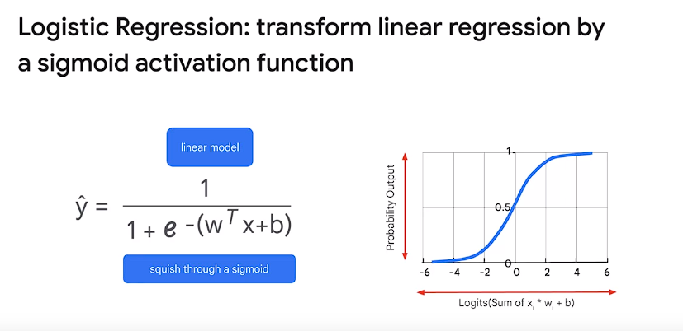

1. **Regularization in Logistic Regression:**
   * Regularization (L1 and L2) is deemed important in logistic regression to prevent overfitting and numerical stability issues.
   * The impact of regularization on model simplicity, weight values, and the avoidance of saturation (vanishing gradient) is discussed.
2. **Calibrated Probability Estimates:**
   * The sigmoid function provides calibrated probability estimates, allowing logistic regression to predict probabilities rather than binary outcomes.
   * The importance of calibration is emphasized for real-world applications.
3. **Overfitting and Early Stopping:**
   * Overfitting is addressed through both regularization and early stopping.
   * Early stopping is described as an approximate equivalent of L2 regularization, and the combination of both is recommended for practical systems.
4. **Threshold Selection and ROC Curve:**
   * The process of choosing a threshold for decision-making is introduced.
   * The Receiver Operating Characteristic (ROC) curve is explained as a tool to visualize the trade-off between true positive and false positive rates at different decision thresholds.
5. **Area Under the Curve (AUC):**
   * AUC is introduced as an aggregate measure of performance across various classification thresholds in the ROC curve.
   * AUC is considered useful for model comparison when the decision threshold is uncertain.
6. **Bias in Predictions:**
   * The importance of checking bias in predictions is highlighted as a means to ensure model performance.
   * Calibration plots are suggested as a tool to identify bias and refine the model.
7. **Generalization and Model Evaluation:**
   * Generalization is emphasized as a primary goal to ensure optimal predictions on new data.
   * The importance of tuning parameters, selecting thresholds, and addressing bias are crucial for effective logistic regression model evaluation.

In summary, the text provides a thorough exploration of logistic regression, covering its principles, challenges, regularization techniques, calibration, model evaluation, and practical considerations for real-world applications.

1. We can use either the tip amount or the sex of the customer as labels in the tips dataset.
2. When treating the tip amount as the label, it's a regression problem because the tip is continuous.
3. Regression problems aim to predict a continuous value of the label using mathematical functions of features.
4. The goal in regression is to minimize the error between predicted and actual continuous values, typically using mean squared error.
5. Treating the sex of the customer as the label is a bad idea because the data for men and women is not clearly separate.
6. Predicting categorical variables like sex falls under classification problems.
7. Classification problems involve creating decision boundaries to separate different classes.
8. In classification, the aim is to minimize misclassification errors, often using cross entropy.
9. Continuous features can be discretized to solve classification problems.
10. Structured data like the tips dataset consists of rows and columns and is a common source for machine learning.
11. Unstructured data includes pictures, audio, or video.
12. Regression can predict gestation weeks from medical data, which is a continuous variable.
13. Linear regression can be used for linear datasets like predicting baby weight in the medical dataset.
14. Classification can also be applied to linear datasets to create decision boundaries.
15. Linear regression and linear classification are both applicable to certain datasets depending on the problem and data characteristics.

Top of Form

1. Automated machine learning is defined by distinguishing it from statistics and deep learning.
2. Machine learning starts with a business requirement, academic requirement, or problem to solve.
3. The machine learning pipeline includes data wrangling, exploration, model training, evaluation, and deployment.
4. An example use case involves predicting consumer spending score and identifying influential features.
5. Different machine learning frameworks like scikit-learn, PyTorch, or TensorFlow can be utilized.
6. Machine learning involves utilizing abundant data for training, testing, and validation, while statistics may use data as is.
7. Outliers are retained in machine learning for training, whereas they might be discarded in statistics.

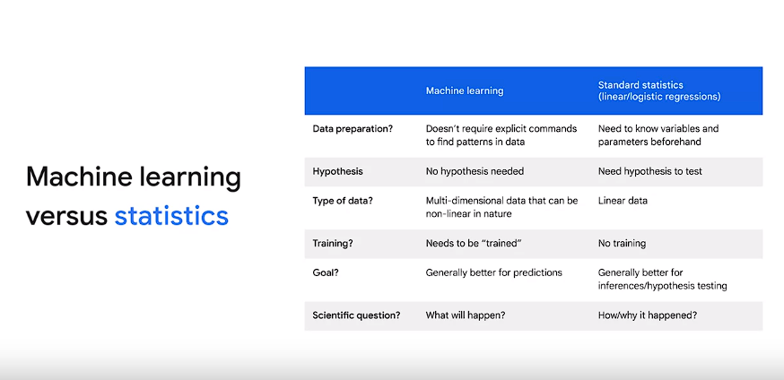

1. Machine learning focuses on prediction, while statistics focuses on understanding relationships between variables.
2. Differences exist between linear and logistic regression in terms of data preparation and hypothesis testing in machine learning versus statistics.
3. Deep learning is a subset of machine learning, **often implemented as supervised learning**.
4. Deep learning requires large datasets and GPUs for training, offering higher accuracy but longer training times.
5. Deep learning allows for more control over hyperparameter tuning compared to other machine learning methods.

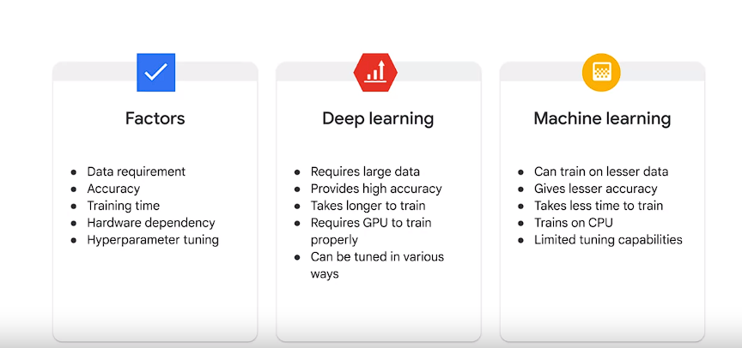

1. Neural networks consist of layers and weights, which are learned during training.
2. Machine learning enables computers to learn from data instead of relying solely on predefined rules.
3. The resulting program from machine learning, including the algorithm and learned parameters, is called a trained model.

Top of Form

Top of Form